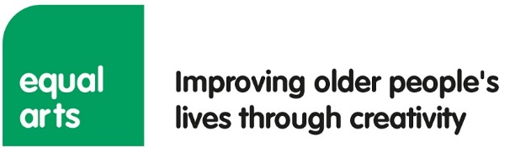

**Personal statement and question**

In reference to the role description and using examples, please outline how your skills and experience make you suitable for this role (800 words max).

Please also answer the question below (450 words max).

**Please note, during our recruitment process Personal Statements will be considered first to create a shortlist at which stage CVs will be reviewed.**

|  |
| --- |
|  |

**Question (450 words max):** What do you feel are the opportunities for developing a creative ageing training offer within the care and cultural sectors? Please briefly address how you would develop these key areas.

|  |
| --- |
|  |