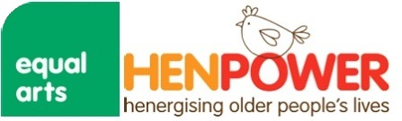

Thank you for getting in touch about current artist vacancies on our HenPower Project at Equal Arts.

Please complete the information requested and return to information@equalarts.org.uk FAO HenPower Artist Role with the names and contacts of two referees and an up to date CV.

Name:

Address:

Postcode:

Region you work in:

Email:

Mobile:

Website:

Name and contact details of two referees:

Art Form/Specialism:

Hen Handling experience?

Experience of working with older people?

Experience of project management?

Current DBS start and end date:

Would you like to be kept up to date with our latest news and how to get involved with our projects?

Expression of interest:

Under the General Data Protection Regulation (GDPR), we need your consent to stay in touch with you.
We will never sell your data and will keep it safe and secure. For more information on our third party service-providers, please visit www.equalarts.org.uk to see our Privacy Policy.
You can unsubscribe or change your details by emailing information@equalarts.org.uk

