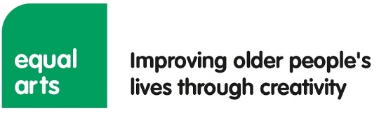
Application Form 2024
Please complete this form and return to hannah@equalarts.org.uk by Monday, September 23, 2024.
Please note, as part of our commitment to Equality, Diversity and Inclusion some information will be redacted prior to shortlisting to ensure the removal of unconscious bias. Details that we redact include (but are not limited to) references to protected characteristics and names of educational institutions.

Role with Equal Arts that you are applying for.
How did you hear about this role?

Section 1: About you
Full name
Address
Email address
Mobile phone
Do you require any arrangements for interview and/or to help you to take up this role? Please tell us if you have any disability-related needs or adjustments which we can support you with.

Section 2: Current and previous experience
Please copy and paste the following table underneath if you need space for more examples or delete if you do not need as many.
Name of organisation
Job title
Dates of employment
Give a brief outline of your responsibilities and achievements (150 words max)

Name of organisation
Job title
Dates of employment
Give a brief outline of your responsibilities and achievements (150 words max)

Name of organisation
Job title
Dates of employment
Give a brief outline of your responsibilities and achievements (150 words max)

Name of organisation
Job title
Dates of employment
Give a brief outline of your responsibilities and achievements (150 words max)

Section 3: Education, training, and professional qualifications
You may add or delete rows in the follow tables as appropriate.
Education
School, college, university, etc. | Qualifications obtained | Date obtained

Training and professional qualifications
Provider | Qualifications obtained | Date obtained
Section 4: References
Please provide the name and contact details of two referees. One referee should be your present or most recent employer (if applicable).
Referee 1
Name
Address
Email
Telephone number
Occupation
Relation to applicant
Referee 2
Name
Address
Email
Telephone number
Occupation
Relation to applicant
Section 5: Declaration
To the best of my knowledge, the information on this application form is correct.
Name: | Signature: | Date:
Please save your completed Application Form as a Word file with your name in the document title and then email it to hannah@equalarts.org.uk Applications sent as a PDF will not be accepted.
Please complete the separate Equality, Diversity and Inclusion Monitoring Word document

Data Protection Statement:
The information you give when completing your Application Form will be used in accordance with the EU General Data Protection Regulation. It will be used to enable the organisation to create electronic and paper records of your application, to enable the application to be processed and to enable the organisation to compile statistics. No statistical information used will be published that would identify you as an individual. The information relating to your application will be kept securely. It will be kept for three months if you are unsuccessful in your job application.

